Simulation-Based Investigation of Microwave Semiconductor Devices and Frequency-Conversion Characteristics of a Microwave Mixer
Aim:
To simulate microwave semiconductor devices and analyze the frequency-conversion characteristics of a microwave mixer.
Procedure:
- Open MATLAB or suitable microwave simulation software.
- Select a microwave semiconductor device, such as a Schottky diode, and define its operating parameters.
- Design a microwave mixer by applying the RF signal and local oscillator (LO) signal.
- Simulate the mixer and observe the output intermediate frequency (IF) signal.
- Analyze the input and output frequencies, conversion loss, and frequency-conversion characteristics.
Code:
clc;
clear;
close all;
%% =========================================================
% MICROWAVE MIXER FREQUENCY-CONVERSION SIMULATION
% =========================================================
%% INPUT PARAMETERS
fRF = 10e9; % RF frequency = 10 GHz
fLO = 9.5e9; % LO frequency = 9.5 GHz
PRF_dBm = -10; % RF input power = -10 dBm
PLO_dBm = 7; % LO power = +7 dBm
ZIF = 50; % IF load impedance = 50 Ohm
%% =========================================================
% FREQUENCY CONVERSION
% ==========================================================
% Difference frequency
fIF = abs(fRF - fLO);
% Sum frequency
fSUM = fRF + fLO;
fprintf('\n');
fprintf('====================================================\n');
fprintf(' MICROWAVE MIXER FREQUENCY-CONVERSION SIMULATION\n');
fprintf('====================================================\n');
fprintf('\nINPUT PARAMETERS\n');
fprintf('RF Frequency = %.2f GHz\n',fRF/1e9);
fprintf('LO Frequency = %.2f GHz\n',fLO/1e9);
fprintf('RF Input Power = %.2f dBm\n',PRF_dBm);
fprintf('LO Power = %.2f dBm\n',PLO_dBm);
fprintf('IF Load = %.2f Ohm\n',ZIF);
fprintf('\nFREQUENCY CONVERSION\n');
fprintf('Difference IF = %.3f GHz\n',fIF/1e9);
fprintf('Difference IF = %.0f MHz\n',fIF/1e6);
fprintf('Sum Frequency = %.3f GHz\n',fSUM/1e9);
%% =========================================================
% CONVERT POWER FROM dBm TO WATTS
% =========================================================
PRF_W = 10^((PRF_dBm-30)/10);
PLO_W = 10^((PLO_dBm-30)/10);
fprintf('\nINPUT POWERS\n');
fprintf('RF Power = %.6f mW\n',PRF_W*1000);
fprintf('LO Power = %.6f mW\n',PLO_W*1000);
%% =========================================================
% CONVERT POWER TO RMS VOLTAGE
% ==========================================================
VRF = sqrt(PRF_W*ZIF);
VLO = sqrt(PLO_W*ZIF);
fprintf('\nRMS INPUT VOLTAGES\n');
fprintf('RF Voltage = %.4f V\n',VRF);
fprintf('LO Voltage = %.4f V\n',VLO);
%% =========================================================
% MIXER SIGNAL GENERATION
% ==========================================================
% Simulation time
fs = 200e9; % Sampling frequency
T = 20e-9; % Simulation duration
t = 0:1/fs:T;
% RF signal
rf_signal = VRF*sqrt(2)*cos(2*pi*fRF*t);
% LO signal
lo_signal = VLO*sqrt(2)*cos(2*pi*fLO*t);
%% =========================================================
% MIXING OPERATION
% ==========================================================
% Ideal multiplier mixer
mixed_signal = rf_signal .* lo_signal;
%% =========================================================
% THEORETICAL FREQUENCY COMPONENTS
% ==========================================================
% Product-to-sum relationship:
%
% cos(A)cos(B)
% = 1/2[cos(A-B)+cos(A+B)]
IF_signal = (VRF*VLO)*cos(2*pi*fIF*t);
SUM_signal = (VRF*VLO)*cos(2*pi*fSUM*t);
%% =========================================================
% TIME DOMAIN RF AND LO SIGNALS
% ==========================================================
figure;
plot(t*1e9,rf_signal,'LineWidth',1.5);
xlim([0 2]);
grid on;
xlabel('Time (ns)');
ylabel('RF Voltage (V)');
title('RF Input Signal - 10 GHz');
%% =========================================================
% LO SIGNAL
% ==========================================================
figure;
plot(t*1e9,lo_signal,'LineWidth',1.5);
xlim([0 2]);
grid on;
xlabel('Time (ns)');
ylabel('LO Voltage (V)');
title('LO Signal - 9.5 GHz');
%% =========================================================
% MIXER OUTPUT
% ==========================================================
figure;
plot(t*1e9,mixed_signal,'LineWidth',1.5);
xlim([0 10]);
grid on;
xlabel('Time (ns)');
ylabel('Mixer Output Voltage (V)');
title('Mixer Output Signal');
%% =========================================================
% FFT ANALYSIS
% ==========================================================
N = length(mixed_signal);
Y = fft(mixed_signal);
P2 = abs(Y/N);
P1 = P2(1:floor(N/2)+1);
P1(2:end-1) = 2*P1(2:end-1);
freq_axis = fs*(0:floor(N/2))/N;
%% =========================================================
% FREQUENCY SPECTRUM
% ==========================================================
figure;
plot(freq_axis/1e9,P1,'LineWidth',1.5);
xlim([0 20]);
grid on;
xlabel('Frequency (GHz)');
ylabel('Magnitude');
title('Mixer Output Frequency Spectrum');
%% =========================================================
% ZOOMED FREQUENCY SPECTRUM
% ==========================================================
figure;
plot(freq_axis/1e9,P1,'LineWidth',2);
xlim([0 11]);
grid on;
xlabel('Frequency (GHz)');
ylabel('Magnitude');
title('RF, LO, IF and Sum Frequency Components');
%% ========================================================
% FREQUENCY MARKERS
% ==========================================================
hold on;
xline(fIF/1e9,'--','IF = 0.5 GHz','LineWidth',1.5);
xline(fSUM/1e9,'--','SUM = 19.5 GHz','LineWidth',1.5);
%% =========================================================
% IF OUTPUT SIGNAL
% ==========================================================
figure;
plot(t*1e9,IF_signal,'LineWidth',1.5);
xlim([0 20]);
grid on;
xlabel('Time (ns)');
ylabel('IF Voltage (V)');
title('Intermediate Frequency Signal - 500 MHz');
%% =========================================================
% MIXER FREQUENCY SUMMARY
% ==========================================================
fprintf('\n');
fprintf('====================================================\n');
fprintf(' MIXER FREQUENCY COMPONENTS\n');
fprintf('====================================================\n');
fprintf('RF Frequency = %.2f GHz\n',fRF/1e9);
fprintf('LO Frequency = %.2f GHz\n',fLO/1e9);
fprintf('IF Difference = %.2f GHz\n',fIF/1e9);
fprintf('IF Frequency = %.0f MHz\n',fIF/1e6);
fprintf('Sum Frequency = %.2f GHz\n',fSUM/1e9);
fprintf('\nThe mixer generates:\n');
fprintf('1. Difference frequency = %.2f GHz\n',fIF/1e9);
fprintf('2. Sum frequency = %.2f GHz\n',fSUM/1e9);
fprintf('\n====================================================\n');
fprintf('CONCLUSION\n');
fprintf('====================================================\n');
fprintf('The 10 GHz RF signal and 9.5 GHz LO signal are mixed.\n');
fprintf('The desired IF output is 500 MHz.\n');
fprintf('The mixer also produces a sum-frequency component at 19.5 GHz.\n');
fprintf('\nSimulation completed successfully.\n');
Output:
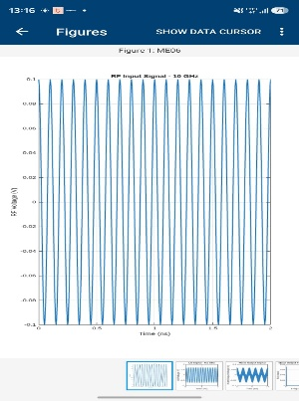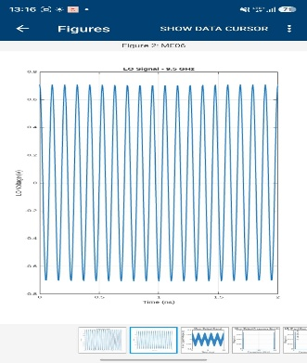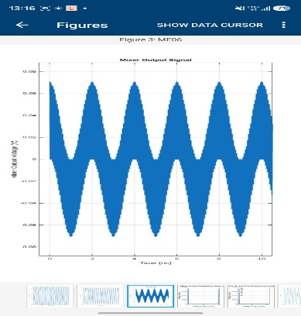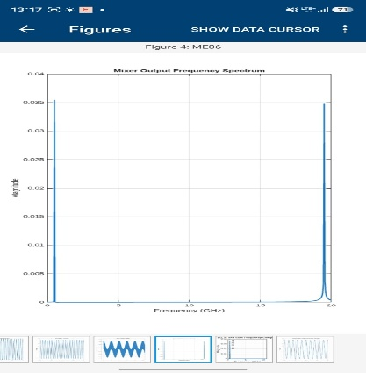
Result:
The microwave semiconductor device and mixer were simulated successfully. The frequency-conversion process was analyzed, and the intermediate frequency was identified from the RF and local oscillator signals.

